UNIVERSITI MALAYSIA TERENGGANU

FACULTY OF COMPUTER SCIENCE AND MATHEMATICS

CSM3103 (K1)

FRONT-END PROGRAMMING

Project Report

(Event Countdown)

Prepared by:

MUHAMMAD IMRAN BIN ABD HAMID

(S66803)

Prepared for:

DR.RABIEI BIN MAMAT

BACHELOR OF COMPUTER SCIENCE (MOBILE COMPUTING) WITH

HONOURS

SEMESTER II 2023/2024

Table of Contents

1.Introduction 3

2. Problem Statement 3

3. Objective 4

4. Application 5

a. Register 5

b. Login 5

c. Add Countdown 6

d. Delete 6

e. Logout 7

# 1.Introduction

Event Countdown is a mobile application that aims to help users with an efficient way to manage and anticipate for their upcoming events. By providing a clear and attractive countdown for various events, this app ensures that users get organized for their upcoming event. The app allows users to create, customize and track event counters, by providing real-time updates and reminders. With the built on hybrid technology, the event counter can be used on both web and mobile platforms, including Android. Using HTML, CSS, JavaScript and the Cordova framework, Event Countdown provides a dynamic and user-friendly interface for seamless event management.

# 2. Problem Statement

Do you have distressing about forthcoming occasions? Is your social life often like a crazy game of juggling, with you searching for time like a last-minute scarce resource? You're not alone. Classical planners as well as the calendar apps are great option, however, when it comes to the excitement and the moment you have to be updated all the times, they are not the best option.

Event Countdown deal with this subject by introducing a user-friendly mobile application which will ease the burden of event management. It is not simply a ticking clock. It is rather your personal helper, repeating important dates, while just keeping excitement in the air. No more the anxiety of being out of touch or dealing with difficult working out how notifications get missed or poor quality interfaces. Event Countdown by its glance-at-a- glance manner of organizing, and its adding a little flavor into the process of preparation, provides a highly fun and simple platform. Say goodbye to paper cuts and night terror of the phone – with the Event Countdown, you can stand by your social calendar with grace and remember all those moments without panic.

# 3. Objective

Event Countdown, developed in this project, will focus on helping users keep track of their important events with ease and anticipation. There are three main purposes for this project which is:

1. Create a user-friendly interface to ensure users can easily create and manage event countdowns.

2. Provide real-time countdowns and reminders to keep users informed about their upcoming events.

3. Allow users to customize and share their countdowns to enhance engagement and participation.

# 4. Application

## a. Register

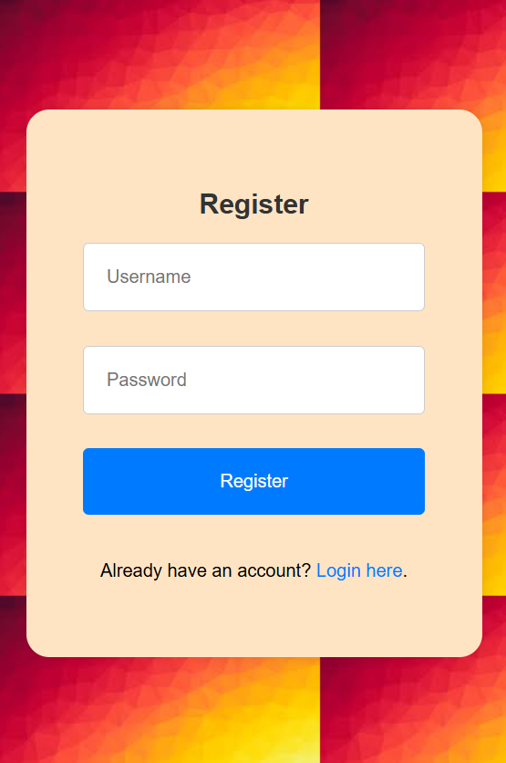

Figure 1.0

## b. Login

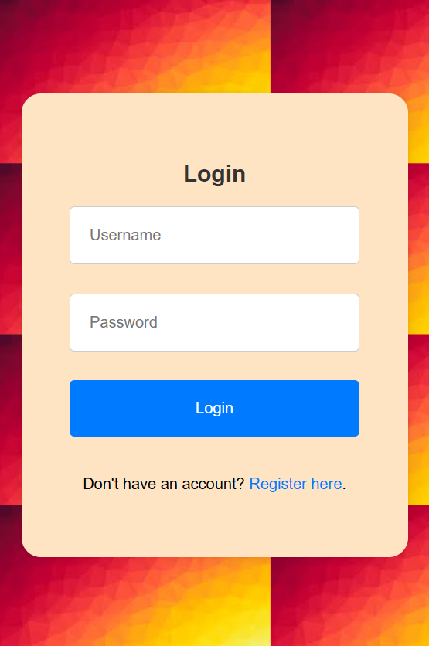

Figure 2.0

## c. Add Countdown

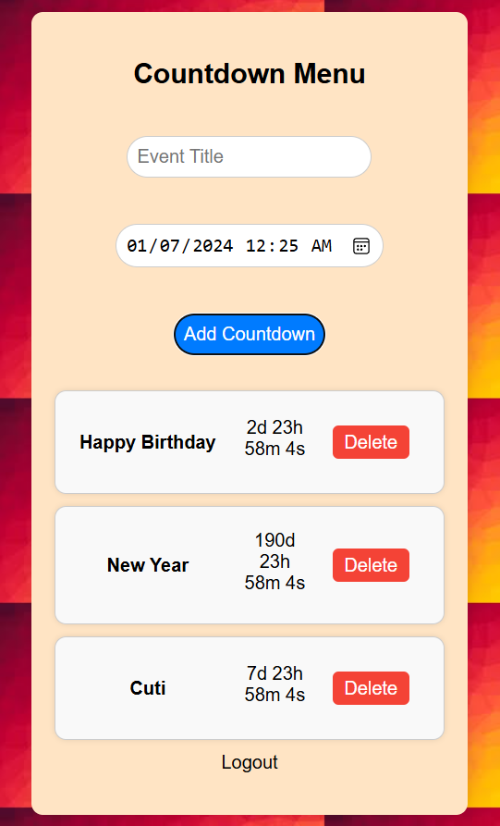

Figure 3.0

## d. Delete

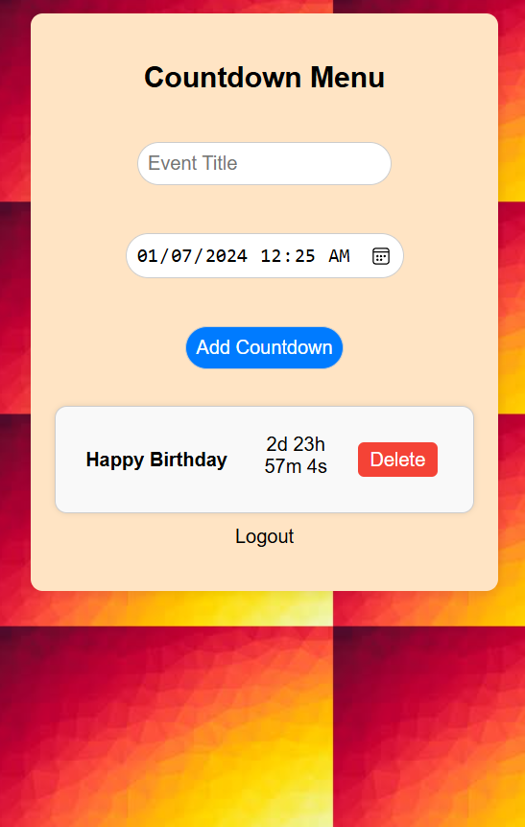

Figure 4.0

## e. Logout

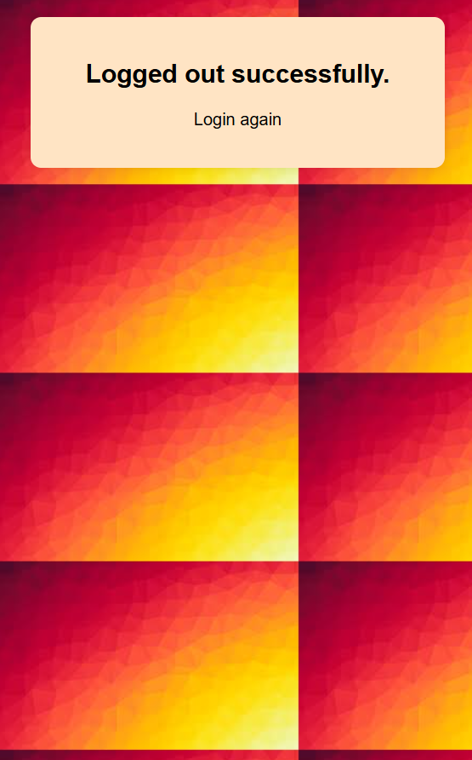

Figure 5.0

Link Github: <https://github.com/S66803/CSM3103-Project>